

**A-1 Uniforms**

**Supervisor:** NGUYỄN HẠ VY

**Semester: 01**

**Batch No: T1.2302.M0**

**Group No: 06**

|  |  |  |
| --- | --- | --- |
| **Order:** | **Full name** | **Enrolment No.** |
| 1. | TRUONG HOAN KHAI | Student1448345 |
| 2. | PHU DUNG KHANH | Student1455754 |
| 3. | NGUYEN ANH TUAN | Student1455776 |
| 4. | NGUYEN XUAN THUAN ANH | Student1449577 |

***Month****: 5* ***Year****: 2023*



This is to certify that

**Mr. TRƯƠNG HOÀN KHẢI**

**Mr. PHÙ DŨNG KHÁNH**

**Mr. NGUYỄN ANH TUẤN**

**Ms. NGUYỄN XUÂN THUẤN ANH**

Have partially Designed & Developed

A-1 Uniform

Submitted by: **Ms. NGUYEN HA VY**

Date Of Issue:

Authorized Signature:

## Table of Contents

Table of Contents 3

Acknowledgement 5

Problem Statement 6

Requirements 7

Business Requirements 7

Functional Requirements 7

High Level Design 8

Site Map 8

Data Flow Diagram 8

Non-Functional Specification 9

Functional Specifications 10

1. Common Use Cases 11

Common Use Cases 11

Common Use Cases Description: 11

UC#1: Common-View Navigation Header 11

UC#2: Common-View Navigation Footer 12

UC#3: Common-View Product Card 13

UC#4: Common-View Web Banner 14

2. View A-1 Uniforms Self-Introduction 16

3. Sign in 18

Process Flows 18

Use Cases 19

Use Case Description: 19

UC#6: Sign In 19

UC#7: Sign Up/ Create Account 20

UC#8: Forgot Password/ Reset your password 21

4. View Homepage 23

Use Cases 23

Use Cases Description 23

UC#9: View Hompage 23

UC#10: View My Cart 26

5. Place Order 29

Process Flows 29

Use Cases 29

Use Cases Description 29

UC#11: Search Product Catalog 29

UC#12: View a Product’s Details 32

UC#13: Check out 34

6. Send Feedback/ Request 38

Use Cases 38

Use Cases Description 38

UC#14: View Contact Information 38

UC#15: Leave a Message 38

THE END 40

# Acknowledgement

First of all, I would like to thank Aptech India for granting us the opportuinity to work on this interesting eProject. We’ve had a great experience.

Secondly, We would like to express my special thanks to our mentor, Ms. Nguyen Ha Vy for the time and effort that she has provided throughout the project. Her helpful advice and suggestions were beneficial to us during the completion of the project.

Last but not least, we hope to have more opportunities to widen our knowledge in the web-developing world and continue life-long learning while improving ourselves in the future.

# Problem Statement

A-1 uniforms was founded in 2016 and since then they have been one of the leading Uniform Manufacturers in the country. they supply many schools in country and they give them the best uniforms. They supply affordable school uniforms for girls and boys. When clients come, they cater to client’s vision. As a team of professionals they understand what clients want and deliver the best results.

At A-1 uniform designs are innovative and there are always fresh and new ideas for each and every client. The textiles are of excellent quality and they make each uniform according to the size requirements given. The fit is ingenious and they provide with the best. A-1 uniform is a part of a continuous strategic process of creative inputs from experts in the field. They consider each client differently and ensure the satisfaction with the end results. Each client is given the uttermostimportance.

The entire team works together to achieve the same goal.

# Requirements

## Business Requirements

Looking at the demands and increasing power of web, the management of A-1 Uniform are looking for hosting a website of their products which maké easier for customers to reach to them.

Our mission is developing the site “A1uniforms.com”

## Functional Requirements

The Web site is to be created based on the following requirements.

1. The home page must describe the keywords or highlight of the shop along

with all navigation link defined.

2. Products should be categorized by Shirts, Skirts, Frocks, P.T. T-shirts, P.T. shorts, P.T. track pants, Belts, Ties, Socks and Logos.

3. The “Contact Us” page should have the Address of the Company and the mail

address which when clicked will invoke the local mail client from where they

can send an email. Address of the Company should be displayed using

GeoLocation API (e.g. GoogleMaps).

4. Contact Us page should also include the address and contact details of various

outlets of A-1 uniforms in the city.

5. About us page

6. Feedback

7. Navigation must be smooth.

8. Color combination must be uniform throughout the project.

# High Level Design

## Site Map

The figure below shows the Sitemap identified for A1uniform.com

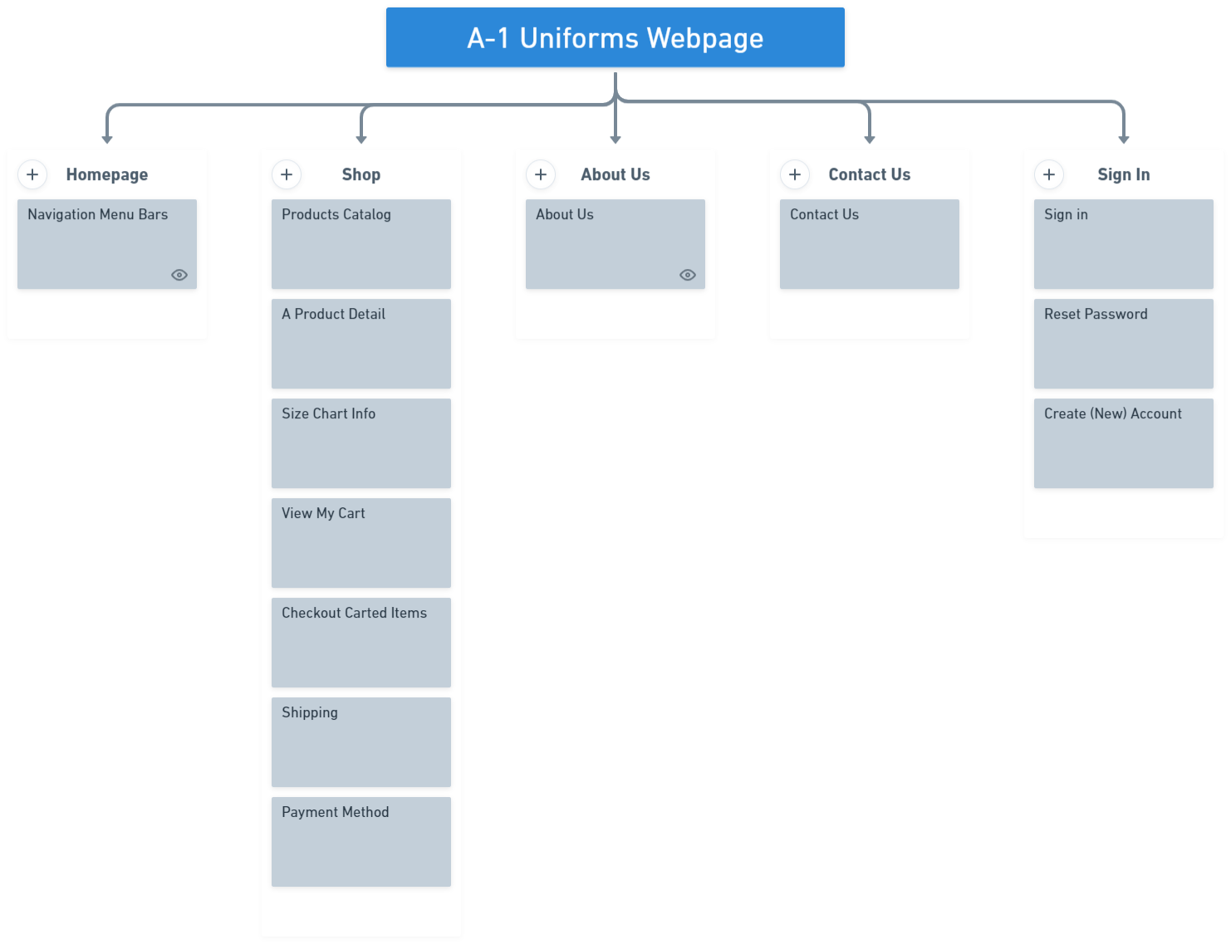

## Data Flow Diagram

The figure below shows the Data Flow Diagram identified for A1uniform.com

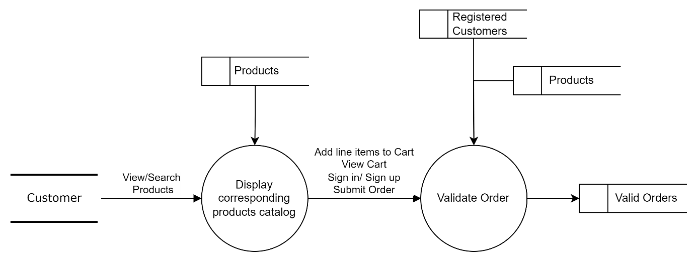

# Non-Functional Specification

The only only non-functionn requirement that we have implemented is Making **all webpages responsively-displayed**.

# Functional Specifications

## Common Use Cases

### Common Use Cases

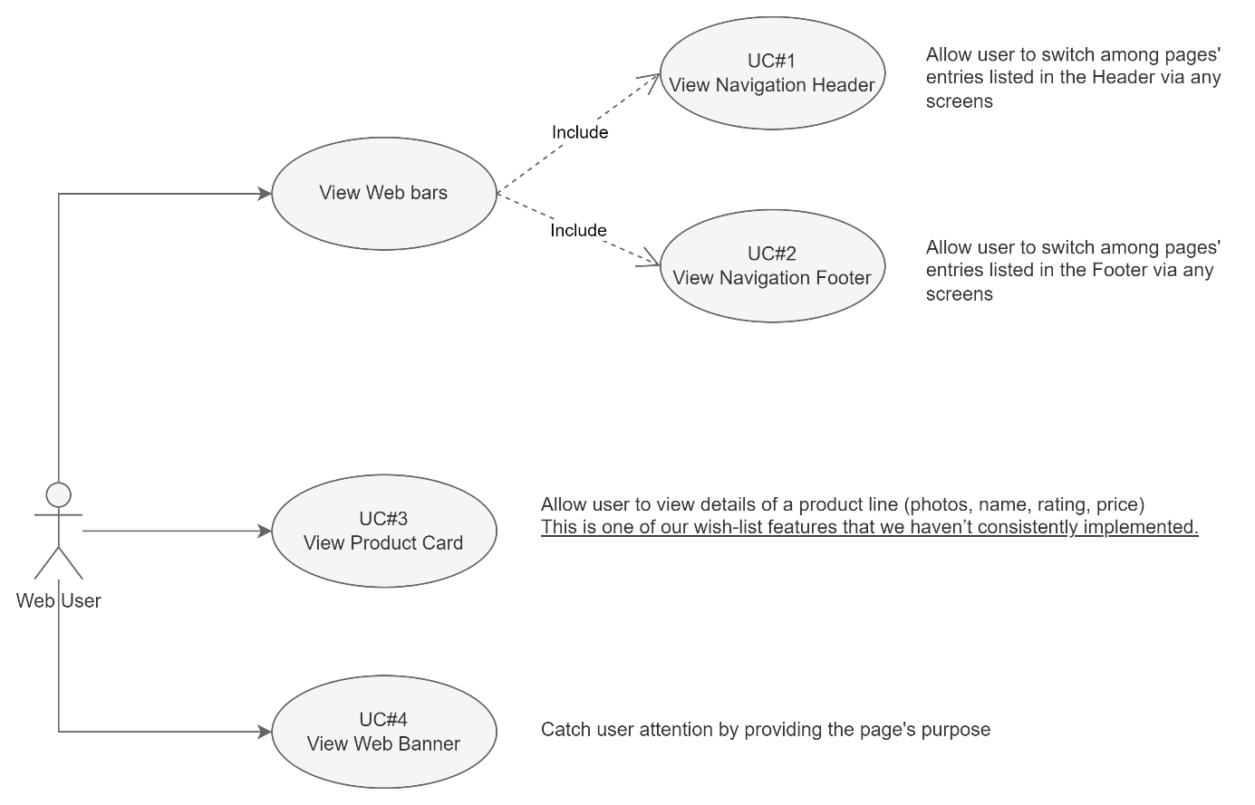

### Common Use Cases Description:

#### UC#1: Common-View Navigation Header

|  |  |
| --- | --- |
| Path | User accesses to the webpage  User view Menu entries in the Header  User interacts with entries via any URL |
| Pre-conditions | None |
| Trigger | On Click |
| Post-condition | System always displays the navigation header with all entries enabled.  On click each entry of the menu, system navigates user to the corresponding page. |











|  |  |  |  |  |  |
| --- | --- | --- | --- | --- | --- |
| Field Name | Control Format | Validation Rule | Data Type | Default Value | Trigger Event |
| The header bar | <section> | Background-color: #E3E6F3 | - | - | - |
| A-1 Logo | Image | Open the Homepage | PNG | Enabled | On Click |
| Shop | Cell (Label) | Open the Product Catalog page | Text | Enabled | On Click |
| About | Cell (Label) | Open the About Us page | Text | Enabled | On Click |
| Contact | Cell (Label) | Open the Contact Us page | Text | Enabled | On Click |
| Cart icon | Icon | Open the View My Cart page | - | Enabled | On Click |

#### UC#2: Common-View Navigation Footer

|  |  |
| --- | --- |
| Path | User accesses to the webpage  User view entries in the Footer  User interacts with enabled entries via any URL |
| Pre-conditions | None |
| Trigger | On Click |
| Post-condition | System displays the navigation footer across the system pages with some entries, that are feasible in this eProject, are enabled. |

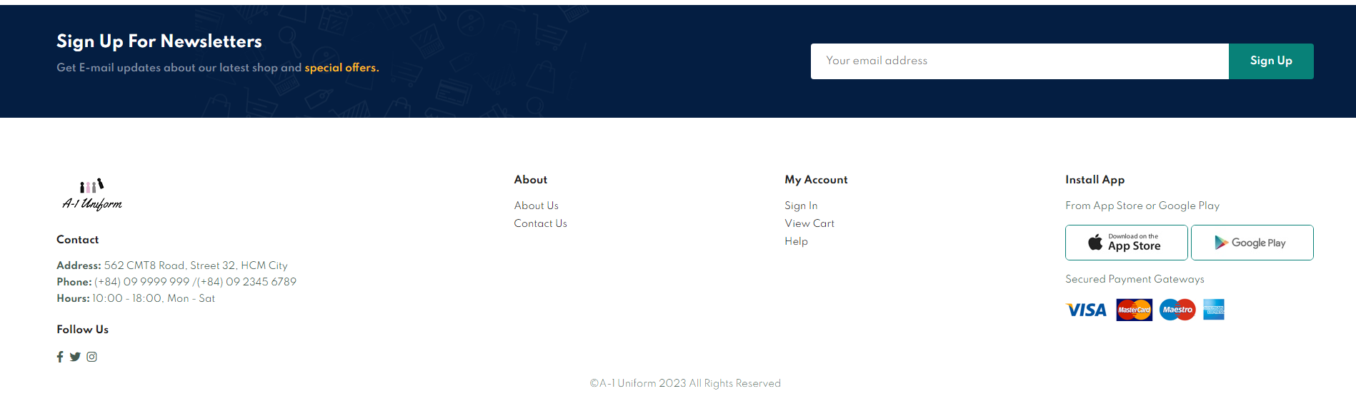

|  |  |  |  |  |  |
| --- | --- | --- | --- | --- | --- |
| Interactive Fields Name | Control Format | Validation Rule | Data Type | Default Value | Trigger Event |
| Your email address | Input Field | Allow free text input  No validation check | - | Placeholder: Your email address | On each character typing |
| Sign Up | Button | No validation check | Text | - | - |
| About Us | Hyperlink Text | System opens the About Us page | Text | - | On Click |
| Contact Us | Hyperlink Text | System opens the Contact Us page | Text | - | On Click |
| Sign In | Hyperlink Text | System opens the Sign In page | Text | - | On Click |
| View Cart | Hyperlink Text | System opens the View My Cart page | Text | - | On Click |
| Help | Hyperlink Text | System opens the Contact Us page>> Leave a message section | Text | - | On Click |

#### UC#3: Common-View Product Card

|  |  |
| --- | --- |
| Path | 1. User view product card in Homepage 2. User views in Product Catalog |
| Pre-conditions | None |
| Trigger | - |
| Post-condition | Product cards are displayed row by row in applicable areas |

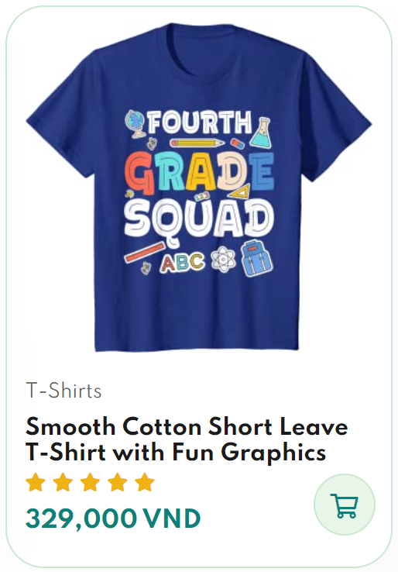

|  |  |  |  |  |  |
| --- | --- | --- | --- | --- | --- |
| Field Name | Control Format | Validation Rule | Data Type | Default Value | Trigger Event |
| <category> | Cell (Label) | Display category of each product | Text | - | - |
| <name> | Cell (Label) | Display name of each product | Text | - | - |
| <rating> | Star Icon | Display the rating of each product  Only be displayed for product with highest rating in Homepage | Icone | 5 starts | - |
| <price> | Cell (Label) | Display the price of each product | CHAR | - | - |
| Cart icon | Icon | On hover, color is constracted.  On Click, system open the corresponding product page | Icon | - | On Click |

#### UC#4: Common-View Web Banner

|  |  |
| --- | --- |
| Path | 1. User accesses to the page (About Us, Contact Us, View My Cart) 2. User views corresponding displayed content. |
| Pre-conditions | None |
| Trigger | On Click |
| Post-condition | System displays corresponding displayed content of each page. |

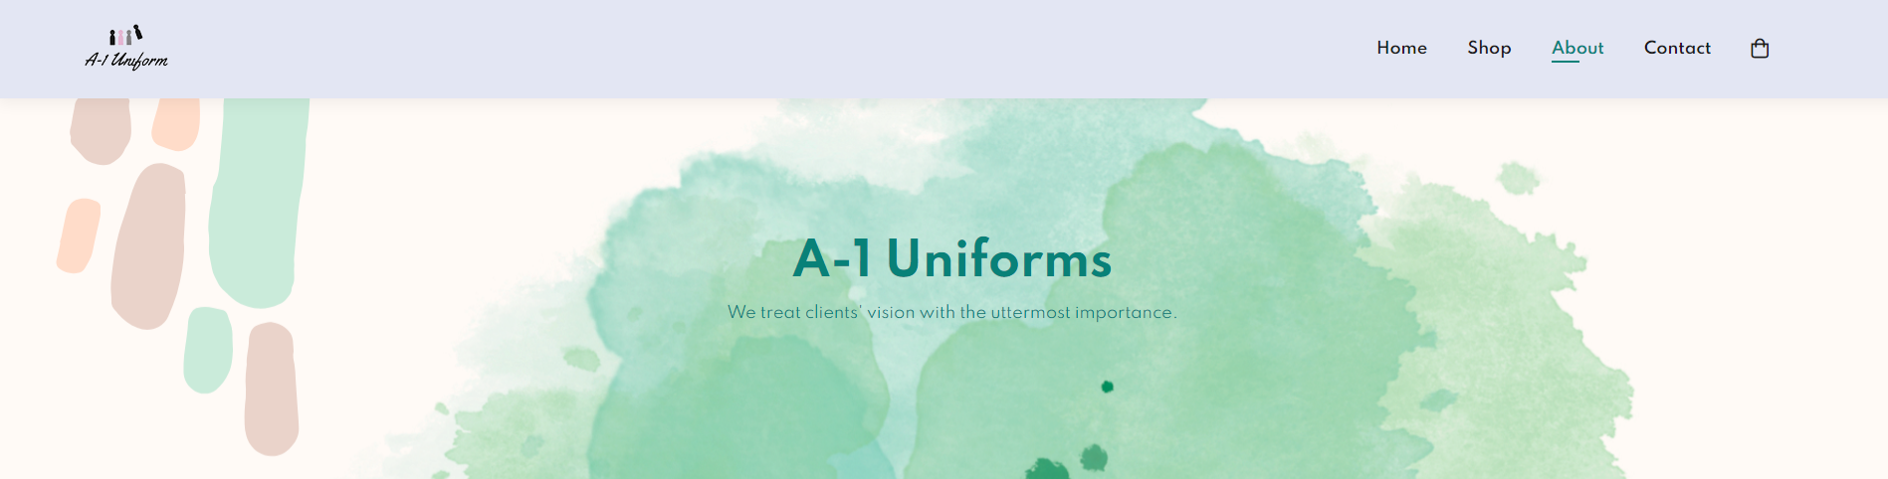

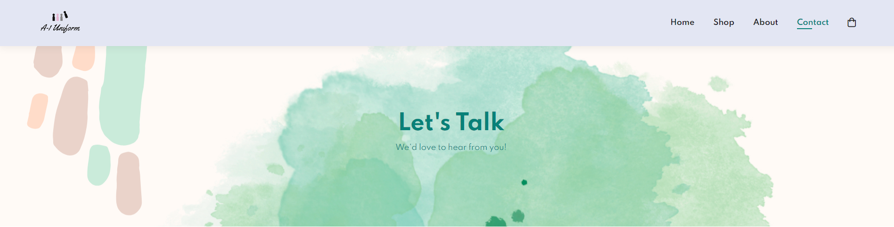

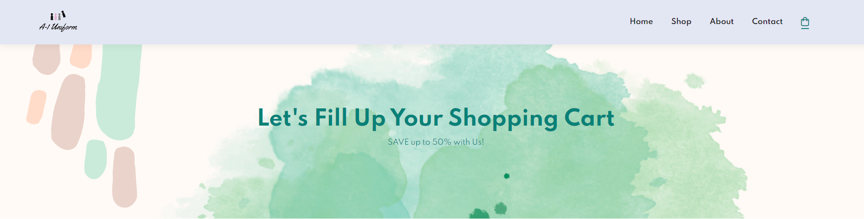

|  |  |  |  |  |  |
| --- | --- | --- | --- | --- | --- |
| Field Name | Control Format | Validation Rule | Data Type | Default Value | Trigger Event |
| Banner | Image | Background Image, refer to img\about\banner.png | PNG | - | - |
| Text | Heading | In About Us page, display “A-1 Uniforms” text.  In Contact Us page, display “Let's Talk” text.  In View My Cart page, display “Let’s Fill Up Your Shopping Cart” text | Text | - | - |
| Sub-Text | Paragraph | In About Us page, display “We treat clients' vision with the uttermost importance.”  In Contact Us page, display We'd love to hear from you!” text.  In View My Cart page, display “SAVE up to 50% with Us” text. | Text | - | - |

## View A-1 Uniforms Self-Introduction

|  |  |
| --- | --- |
| Path | 1. User access the About Us page from Navigation Header 2. User access the About Us page from Navigation Footer |
| Pre-conditions | None |
| Trigger | On Click |
| Post-condition | The About Us page is displayed for user viewing. |

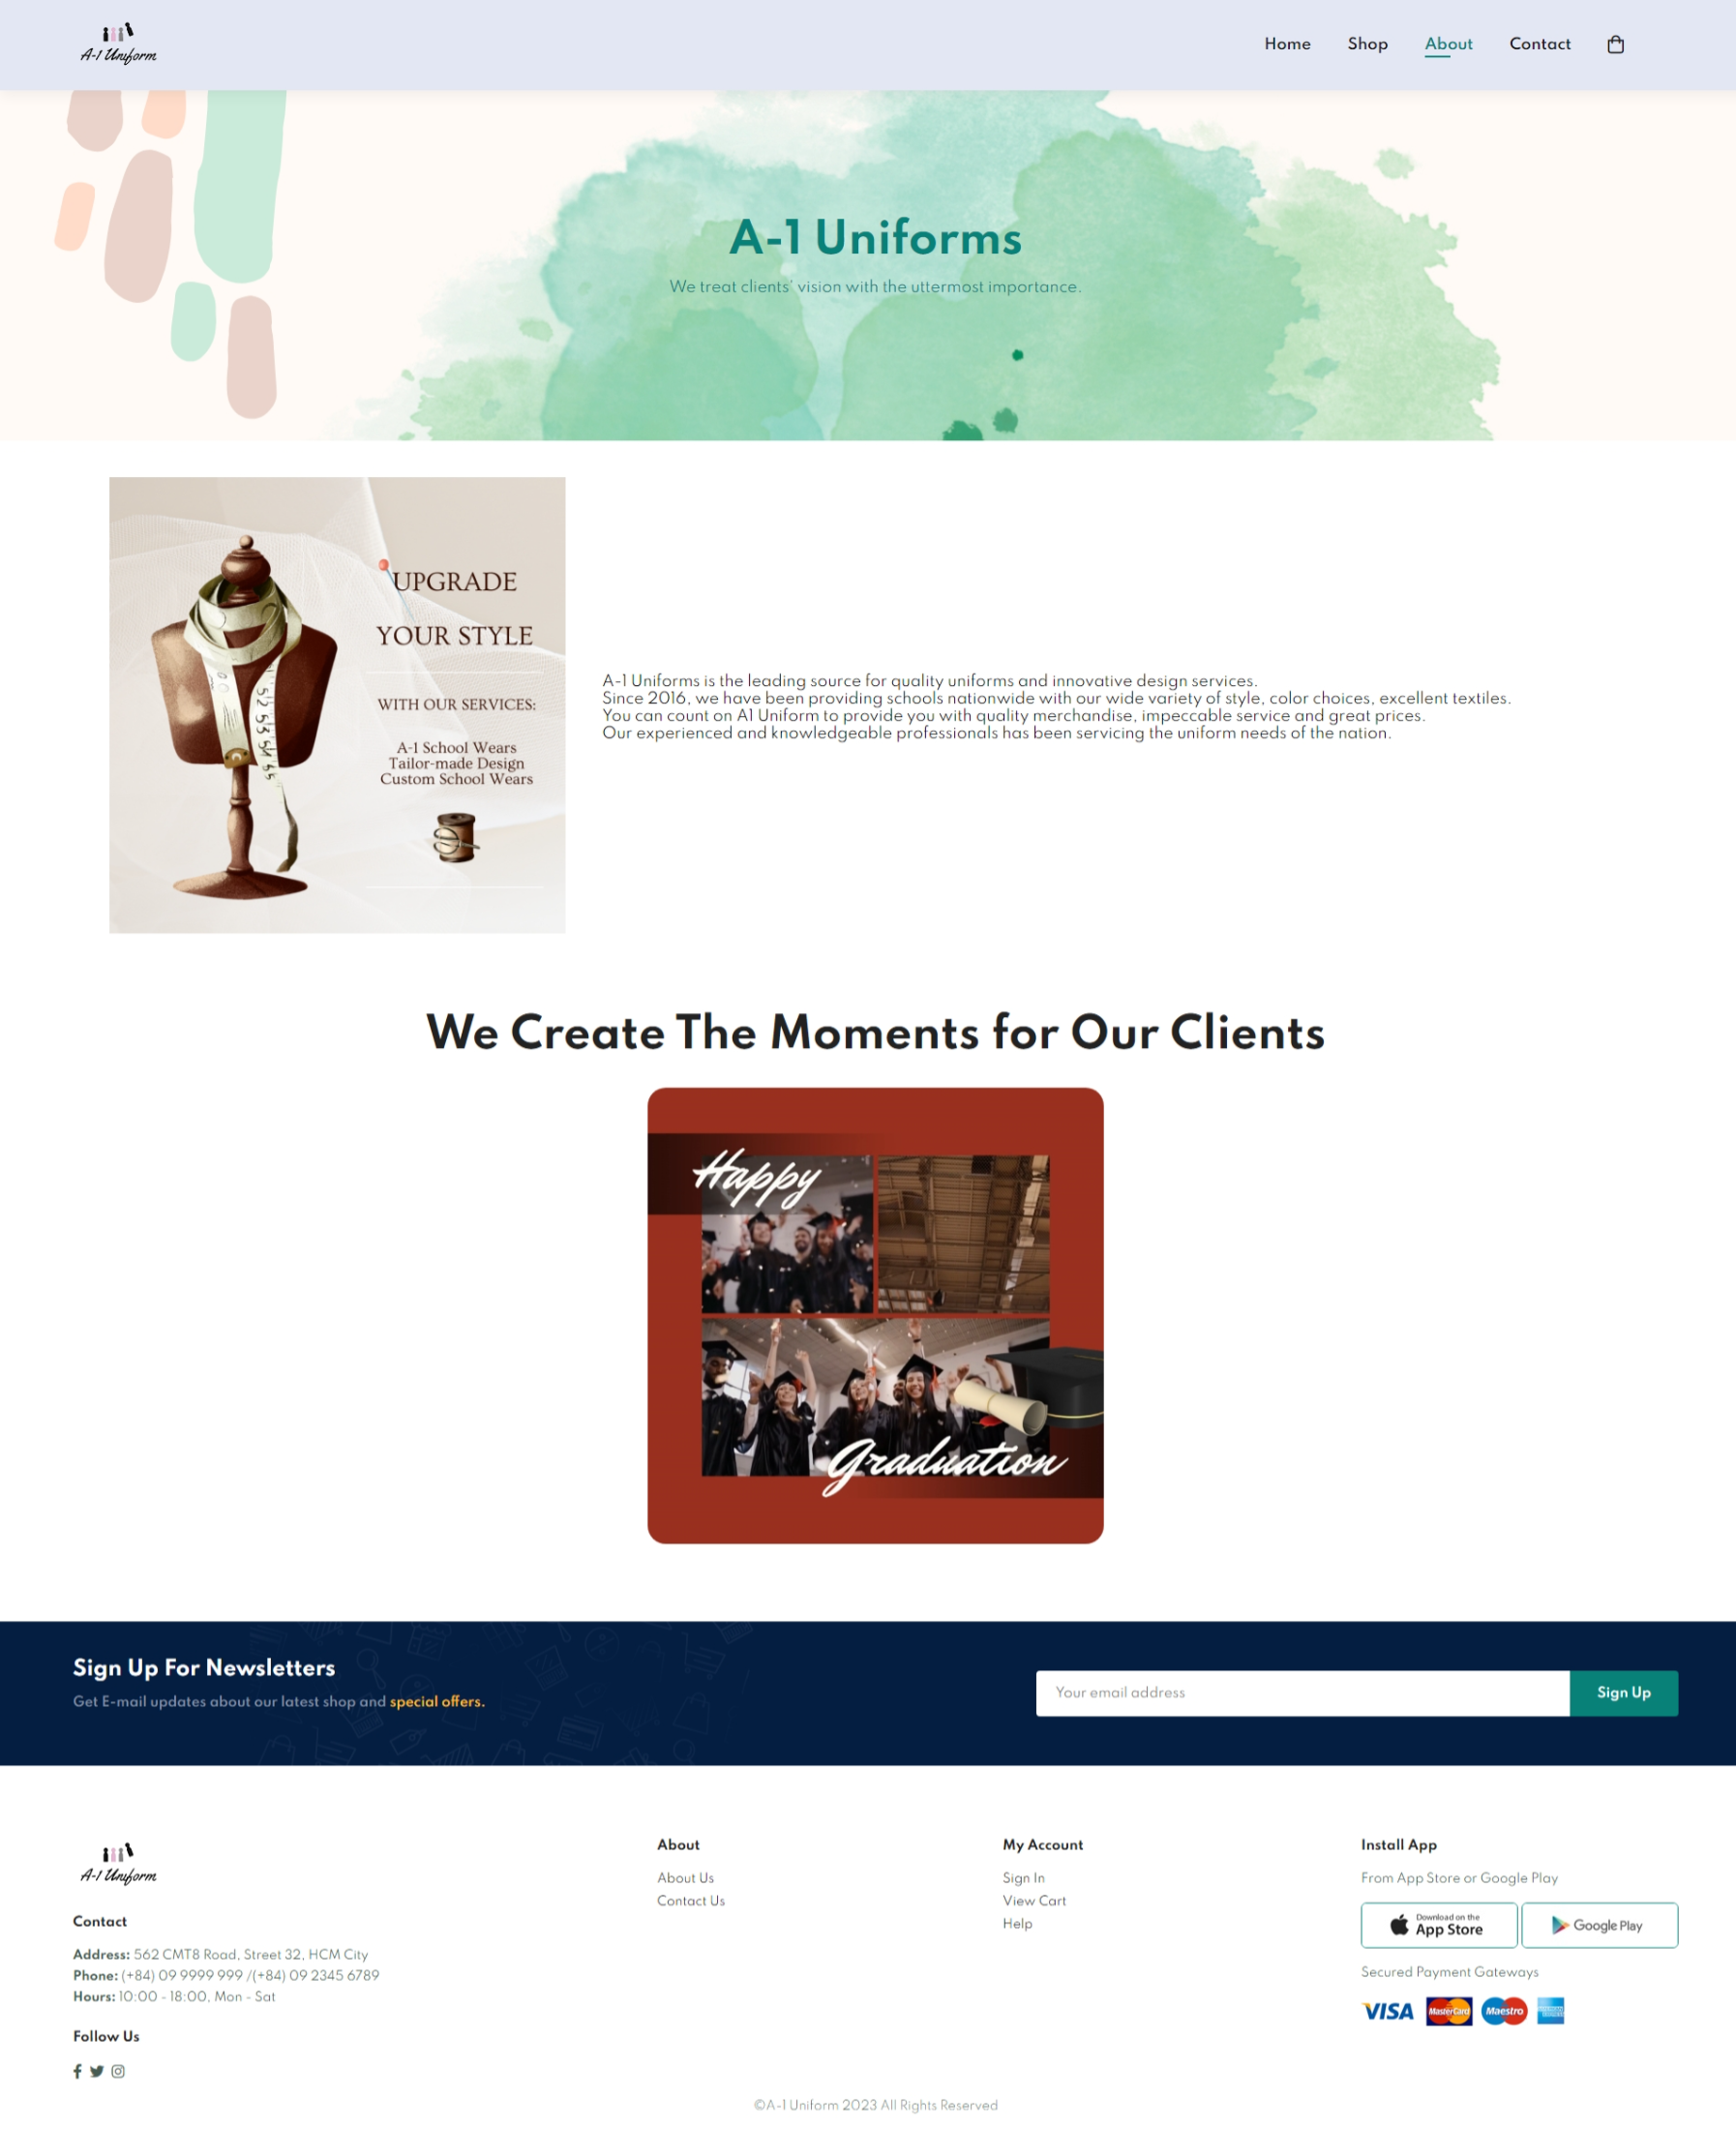

|  |  |  |  |  |  |
| --- | --- | --- | --- | --- | --- |
| Field Name | Control Format | Validation Rule | Data Type | Default Value | Trigger Event |
| <image> | Image | Image inserted, refer to img\about\AboutUs.png | PNG | Displayed | - |
| <introduction text> | <p> | Display the paragraph text:  “A-1 Uniforms is the leading source for quality uniforms and innovative design services. Since 2016, we have been providing schools nationwide with our wide variety of style, color choices, excellent textiles. You can count on A1 Uniform to provide you with quality merchandise, impeccable service and great prices. Our experienced and knowledgeable professionals has been servicing the uniform needs of the nation.” | Text | Displayed | - |
| <customer experience demo> | <heading> | Display “We Create The Moments for Our Clients” text. | Text | Displayed | - |
| <video> | <video> | Video is auto-played, muted, and automatically repeated. | mp4 | Autoplay | - |

## Sign in

### Process Flows

The figure below shows the **Sign Up** flow identified for the system

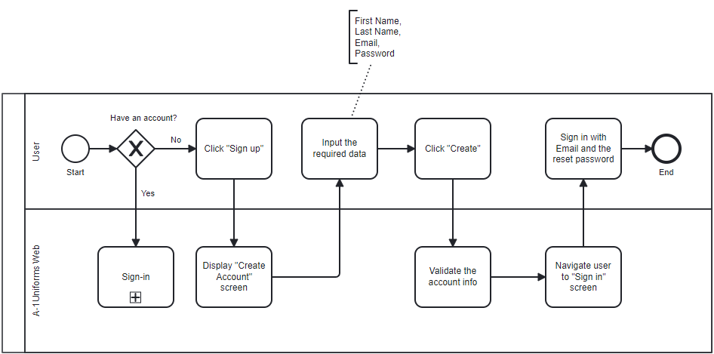

The figure below shows the **Sign In** flow identified for the system

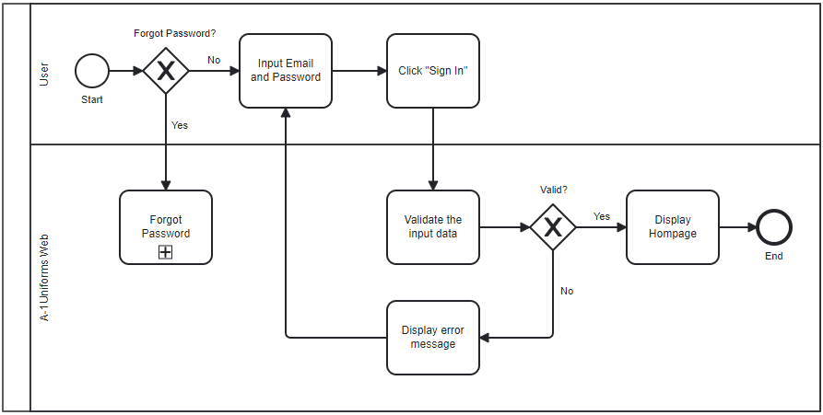

The figure below shows the **Forgot Password** flow identified for the system

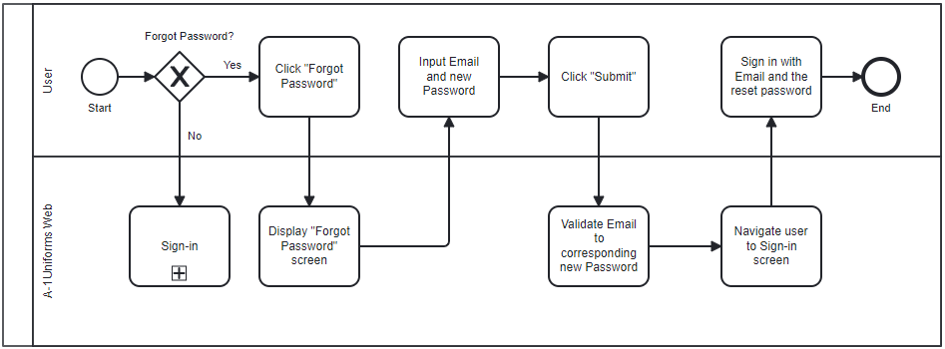

### Use Cases

|  |  |  |
| --- | --- | --- |
| # | UC Name | Description |
| 6 | Sign In | Allows user to log into A-1 Uniforms with corrsesponding user email and password. |
| 7 | Sign Up | Allows user to create a new account to log into A-1 Uniforms |
| 8 | Forgot Password | Allows user to reset password in case he/she forgets his/ hers. |
|  | Logout | Allows user to log out of the A-1 Uniforms system.  This is one of our wish-list features that we haven’t implemented yet. |

### Use Case Description:

#### UC#6: Sign In

|  |  |
| --- | --- |
| Path | User accesses Sign In screen via any URL of the system (Footer >> Sign In). OR  User is requested to Sign In upon checking out his/her shopping cart.  2. User inputs his/her Email and Password to log into the system. |
| Pre-conditions | User account is setup successfully  The password must be valid |
| Trigger | Sign In button On Click |
| Post-condition | Success:  System send Success Reponse and redirect users to the Homepage with user’s corresponding username.  Fail:  Display Error Messages:  “Email and Password are not valid.” |

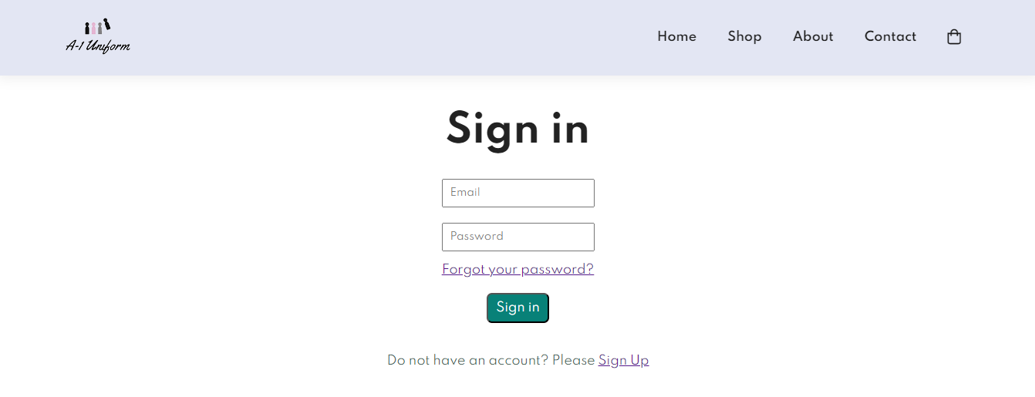

|  |  |  |  |  |  |
| --- | --- | --- | --- | --- | --- |
| Field Name | Control Format | Validation Rule | Data Type | Default Value | Trigger Event |
| Sign In | Cell (Label) | Display “Sign in” text | text | - | - |
| Email | Input Field | On Hover, display “Please fill out this field” tooltip.  On Click, suggest recently-input Email.  Be mandatory and user-editable.  Must be in email format (…@...) | email | Display placeholder: Email | On each character typing |
| Password | Input Field | Accept free text input  Be mandatory and user-ed.itable. | Free text | Display placeholder: Password | On each character typing |
| Forgot your password | Text | On Click, navigate user to Reset your password screen. | text | - | On Click |
| Sign In | Button | System prompts the success respone “Sign in successfully!”. | text | - | On Click |

#### UC#7: Sign Up/ Create Account

|  |  |
| --- | --- |
| Path | User accesses Create Account via Sign In screen  User is requested to have an account to continue.  2. User inputs his/her First Name, Last Name, Email and Password to create his/her new account. |
| Pre-conditions | None |
| Trigger | Create button On Click |
| Post-condition | Success:  System send Success Reponse and redirect users to the Sign In page.  Fail:  Display Error Responses “Account Not Created” |

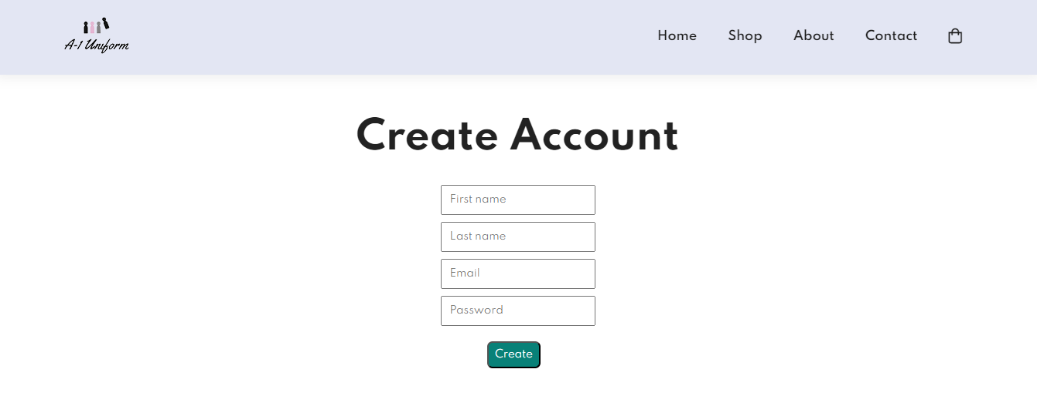

|  |  |  |  |  |  |
| --- | --- | --- | --- | --- | --- |
| Field Name | Control Format | Validation Rule | Data Type | Default Value | Trigger Event |
| Create Account | Cell (Label) | Display “Create Account” text | text | - | - |
| First Name | Input Field | Accept free text input  Be mandatory and user-ed.itable. |  | Display placeholder: First name | On each character typing |
| Last Name | Input Field | Accept free text input  Be mandatory and user-ed.itable. |  | Display placeholder: Last name | On each character typing |
| Email | Input Field | Accept free text input  Be mandatory and user-editable.  Must be in email format (…@...) | email | Display placeholder: Email | On each character typing |
| Password | Input Field | Accept free text input  Be mandatory and user-ed.itable. | Free text | Display placeholder: Password | On each character typing |
| Sign In | Button | System prompts the success respone “Create Account successfully!”. | text | - | On Click |

#### UC#8: Forgot Password/ Reset your password

|  |  |
| --- | --- |
| Path | 1. User accesses Reset your password screen via Sign In screen  2. User inputs his/her Email and new Password to reset the forgotten. |
| Pre-conditions | Email must be valid |
| Trigger | Submit button On Click |
| Post-condition | Success:  System send Success Reponse and redirect users to the Sign In page.  Fail:  Display Error Messages:  “Email and Password are not valid.” |

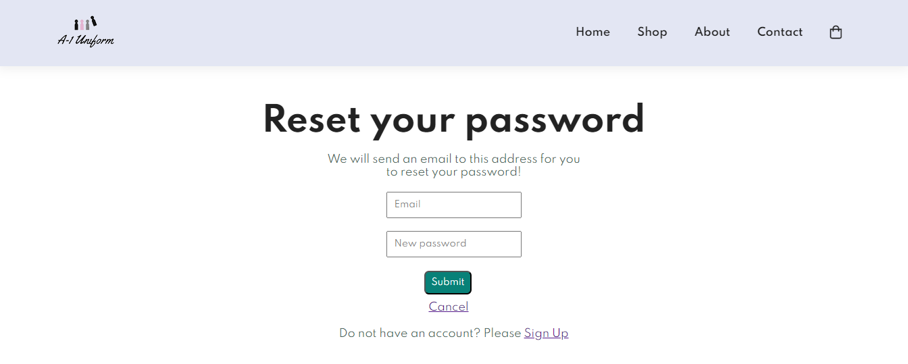

|  |  |  |  |  |  |
| --- | --- | --- | --- | --- | --- |
| Field Name | Control Format | Validation Rule | Data Type | Default Value | Trigger Event |
| Reset your password | Cell (Label) | Display “Reset your password” text | text | - | - |
| Tooltip | Cell (label) | Display “We will send an email to this address for you to reset your password” text paragraph. |  | - | - |
| Email | Input Field | Accept free text input  Be mandatory and user-editable.  Must be in email format (…@...) | email | Display placeholder: Email | On each character typing |
| Password | Input Field | Accept free text input  Be mandatory and user-editable. | Free text | Display placeholder: New Password | On each character typing |
| Sign In | Button | On Click, System prompts the success respone “Reset password successfully!”. | text | - | On Click |

## View Homepage

### Use Cases

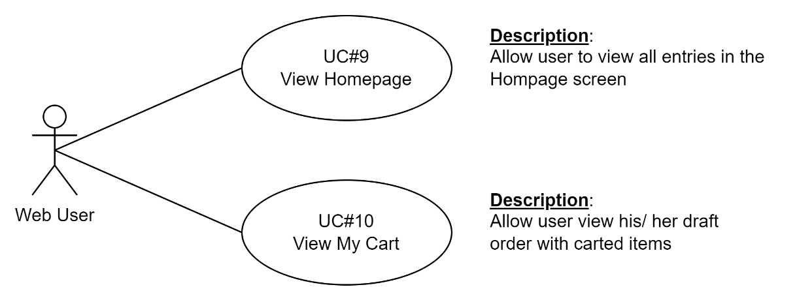

### Use Cases Description

#### UC#9: View Hompage

|  |  |
| --- | --- |
| Path | Scenario 1: User accesses the Homepage directly.  Scenario 2:  User signs into the system successfully.  Homepage screen is displayed by default.  Scenario 3:  User checks out his/ her shoppign cart.  User is asked to sign in but he/she does not have an account.  User sign up for a new account successfully.  >>Scenario 2  Scenario 4:  User is signing in but forgets password.  User reset his/ her password successfully  >> Scenario 2 |
| Alternative Path | At any pages in the system, user clicks either the A-1 Uniform logo placed at left top or Home entry placed in the main menu of the header navigation bar. |
| Pre-conditions | None |
| Trigger | Relevant components On Click |
| Post-condition | The Hompage is displayed with all entries enabled. |

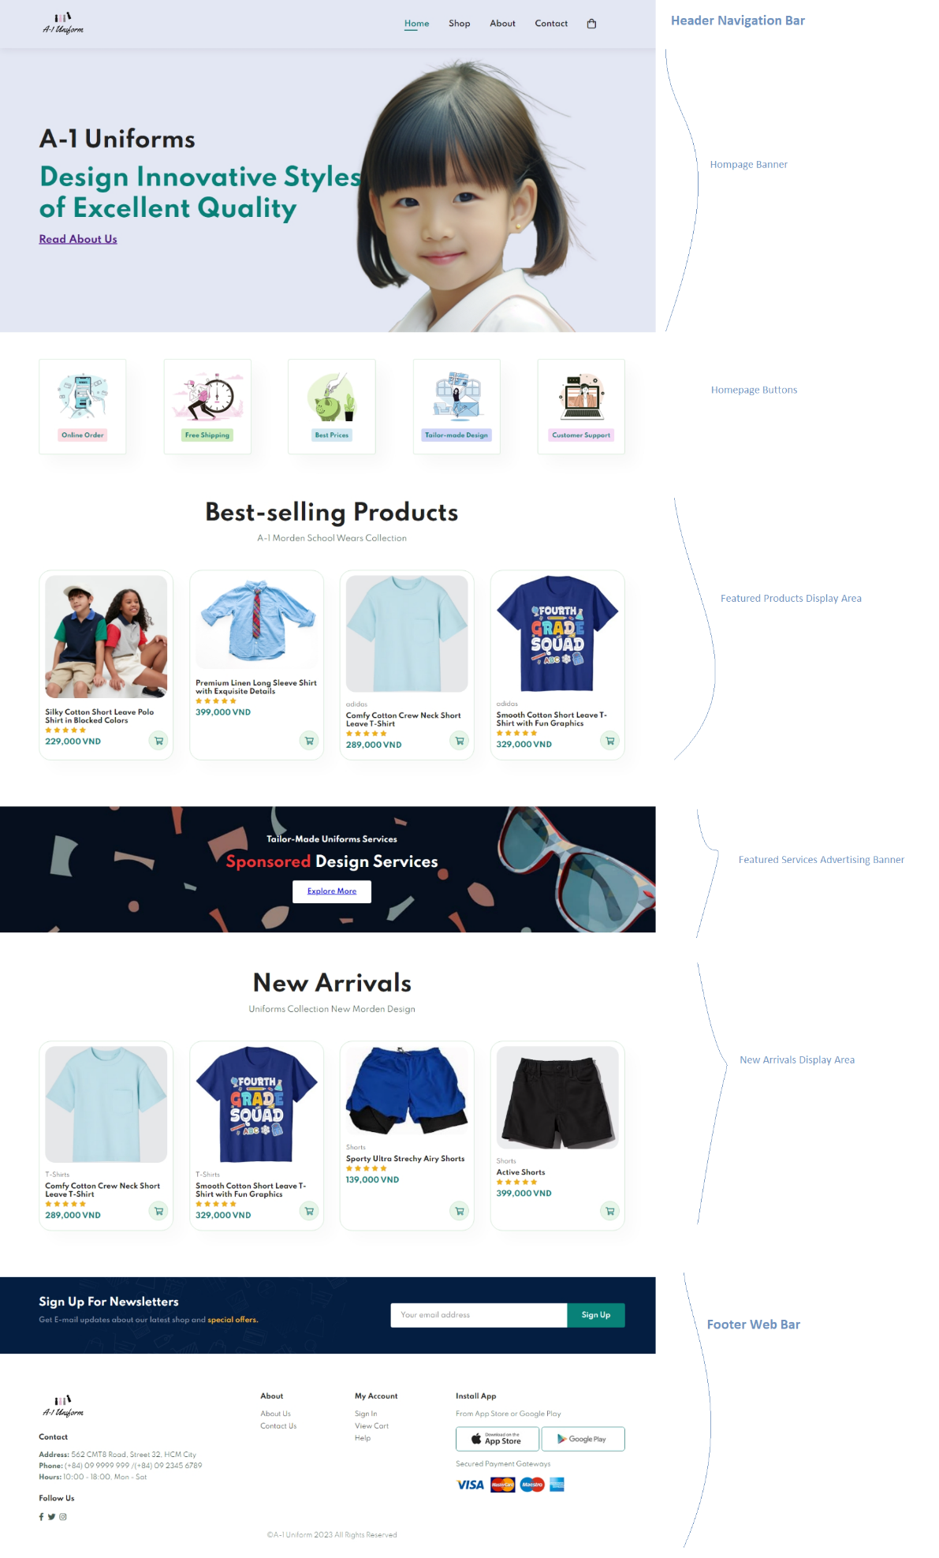

|  |  |  |  |  |  |
| --- | --- | --- | --- | --- | --- |
| Field Name | Control Format | Validation Rule | Data Type | Default Value | Trigger Event |
| Header Navigation Bar  Refer to The Common Use Cases | | | | | |
| Homepage Banner  Background image: can be referred from css\style.css | | | | | |
| A-1 Uniform | Heading 2 | Display “A-1 Uniforms” text  Color: #222222  Not user-editable | text | - | - |
| Design Innovative Styles of Excellent Quality | Heading 1 | Display “Design Innovative Styles of Excellent Quality” text paragraph.  Color: #088178  Not user-editable | text | - | - |
| Read About Us | Heading 4 | Display “Read About Us” text with hyperlink to the About Us page  After-click Color: #551A8B  Not user-editable | text | - | On Clickchi |
| Homepage Buttons  Display the key selling points of A-1 Uniforms which catch customers’ attention by both informative and visual presentation.  No validation rule is attached. Except for the CSS Style, which can be referred from class="fe-box" in css\style.css | | | | | |
| Featured Products Display Area  Display maximum four product cards in a row.  Products are being displayed in this area have the best ratings in ascending order (This is one of our wish-list features that we haven’t implemented yet.)  For a product card specification, please refer to The Common Use Cases  Each product card has product image, name, rating, and price. | | | | | |
| Best-selling Products | Heading 2 | Display “A-1 Uniforms” text  Color: #222222  Not user-editable | text | - | - |
| A-1 Morden School Wears Collection | <p> | Display “A-1 Morden School Wears Collection” text | Text | - | - |
| Product Card | <div> | On Click, navigate user to the corresponding product detail page | - | - | On Click |
| Product Card | Icon | On Click, navigate user to the corresponding product detail page  On hover:  background-color: #088178;  color:#FFFFFF | - | Color: #088178;  Background-color: #e8f6ea;  Border: 1px solid #cce7d0 | On Click |
| Featured Service Advertisting Banner  Background image: can be referred from css\style.css | | | | | |
| Tailor-Made Uniform by A-1 Uniforms | Heading | Display “Tailor-Made Uniform by A-1 Uniforms” text  Color: #FFFFFF  Not user-editable | text | - | - |
| Sponsored Design Services | Heading | Display “Sponsored Design Services” text  Color: #FFFFFF  Not user-editable | text | - | - |
| Explore More | Button | On Click, system navigates user to the Leave a message section of the Contact Us page.  On hover, background-color: #088178 | text | - | On Click |
| New Arrivals Display Area  Display maximum four product cards in a row.  Products are being displayed in this area have the most recent stock-in date and best ratings in ascending order (This is one of our wish-list features that we haven’t implemented yet.)  For a product card specification, please refer to The Common Use Cases | | | | | |
| New Arrivals | Heading 2 | Display “New Arrivals” text  Color: #222222  Not user-editable | text | - | - |
| Uniforms Collection New Morden Design | <p> | Display “Uniforms Collection New Morden Design” text | Text | - | - |
| Footer Web Bar  Refer to The Common Use Cases | | | | | |

#### UC#10: View My Cart

|  |  |
| --- | --- |
| Path | 1. On the right corner of the navigation bar,  Icon 2. Systems displays View My Cart screen |
| Pre-conditions | None |
| Trigger | The icon  On Click |
| Post-condition | My Cart screen is displayed |

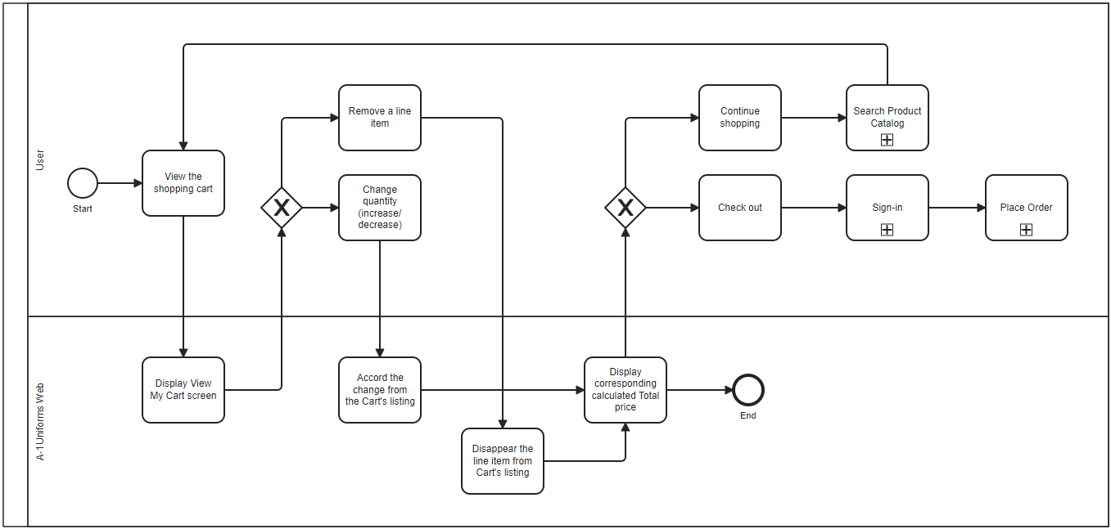

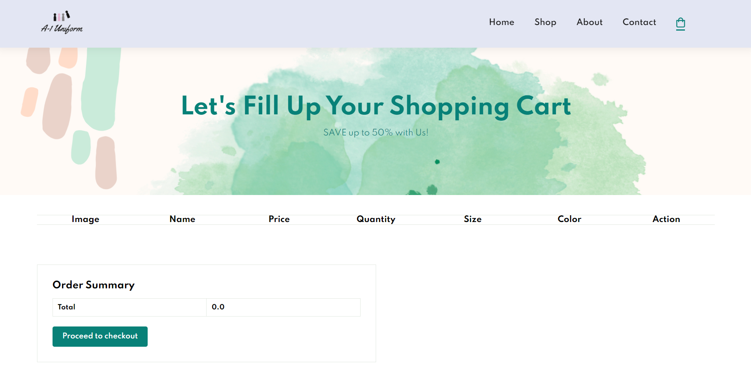

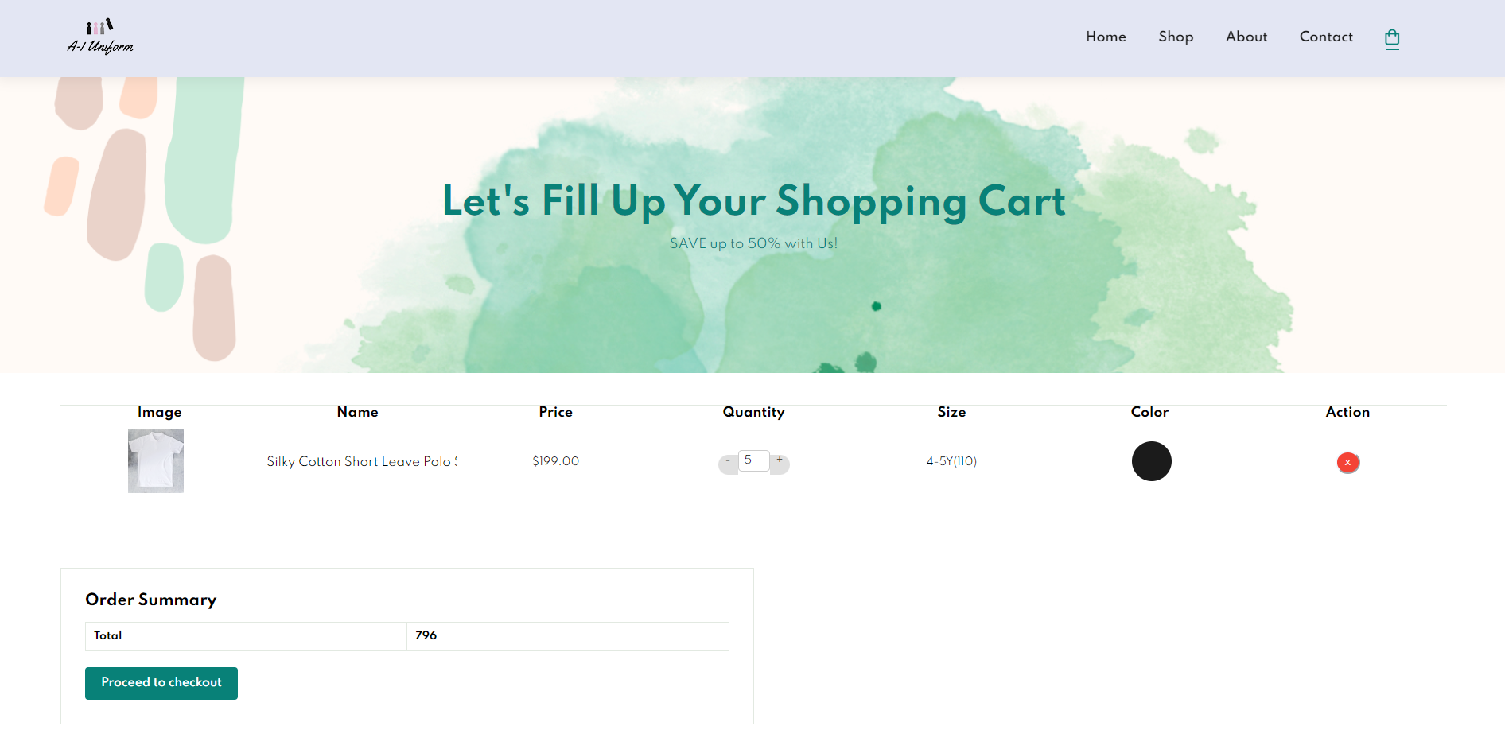

|  |  |  |  |  |  |
| --- | --- | --- | --- | --- | --- |
| Field Name | Control Format | Validation Rule | Data Type | Default Value | Trigger Event |
| Notification Cart Icon | Icon | On hover, its color changes  to (#088178).  On Click, the system opens View My Cart screen with table listing:   * Showing blank if no items in cart; * Showing all carted items’ details (no max limitation).   The Cart icon shows the total number of draft line items created by the viewing user under the following rules:   * If no chosen item, show only icon without number. * No min-max range is applied. | Icon +  Integer Number | - | On Click |
| Column Labels | Each Column contains the corresponding data of each carted item for each data row | | | | |
| Image | Cell (label) | Column contains the images | image | - | - |
| Name | Cell (label) | Column contains the product names | text | - | - |
| Price | Cell (label) | Column contains the unit prices | Positive number | - | - |
| Quantity | Cell (label) | Column displays the added quantity  On Click, allow users to modify | Input Field;  Increment Decrement plus(+) minus (-) buttons | - | On Click |
| Size | Cell (label) | Column contains the chosen sizes | Text | - | - |
| Color | Cell (label) | Column contains the chosen colors | Button with border-radius 50% | - | - |
| Action | Cell (label) | Column contains the remove icons | Button | - | - |
| Order Summary | Heading | Display “Let’s Fill Up Your Shopping Cart” text. | Text | - | - |
| Total | Cell (Label) | Display the total calculated price of all carted items | Positive Number | 0.0 | Add/Remove item to/from Cart |
| Proceed to checkout | Button | Display alert “Please log in to proceed with payment” | Text | Enabled | On Click |

## Place Order

### Process Flows

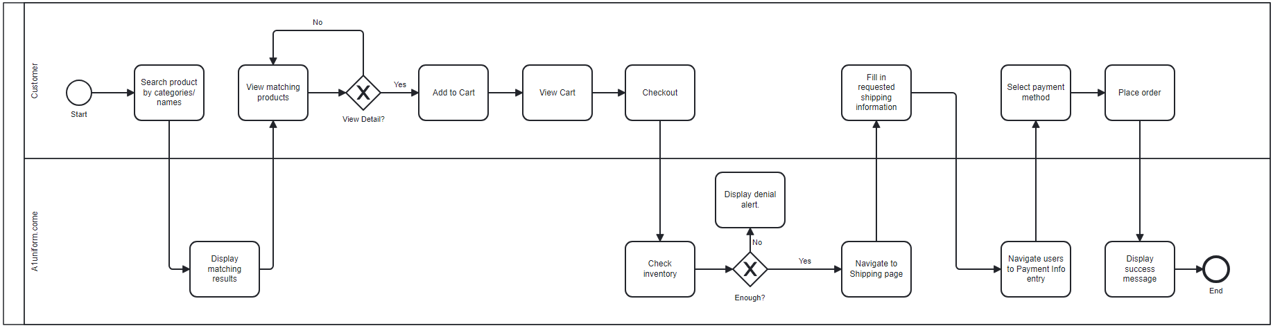

### Use Cases

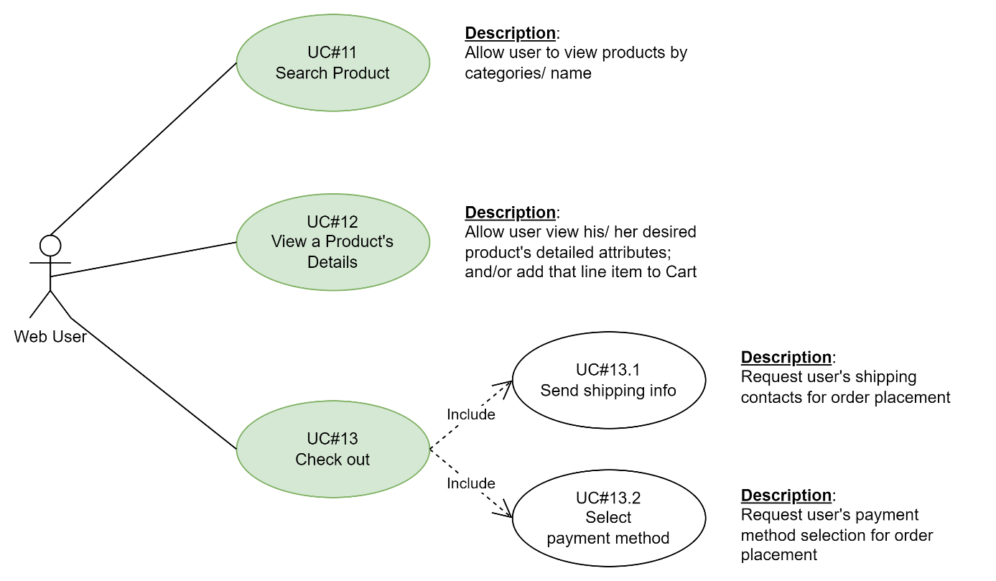

### Use Cases Description

#### UC#11: Search Product Catalog

**UC#11 | Activity Flow**

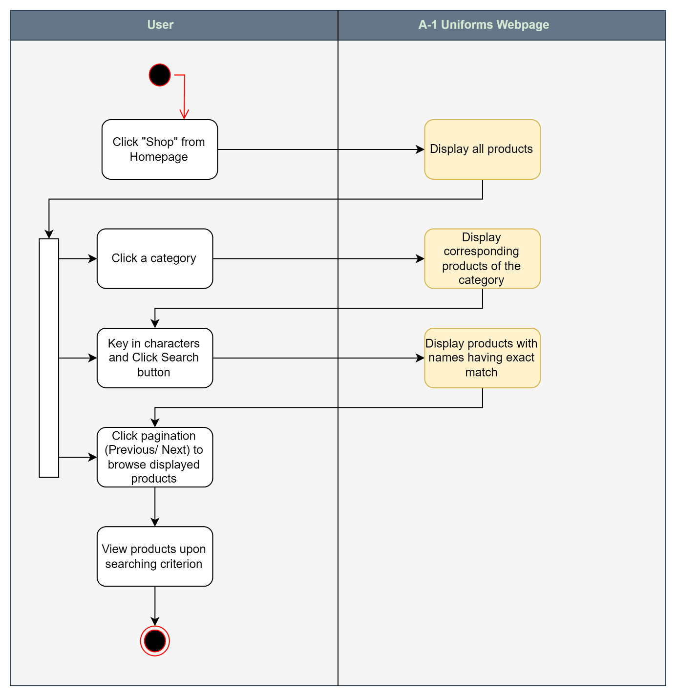

**UC#11 | Screenshot**

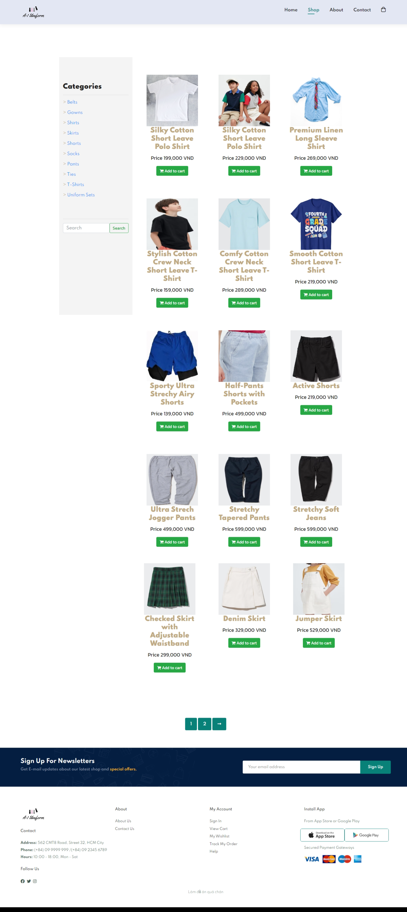

**UC#11 | Entry Fields**

|  |  |  |  |  |  |
| --- | --- | --- | --- | --- | --- |
| Field Name | Control Format | Validation Rule | Data Type | Default Value | Trigger Event |
| Category | Single-Selection List | Display the list of all available product categories.  A category On Click, system display corresponding products of that category.  Selection on category is based on single filtering criterion. | CHAR | All products are displayed | On Click |
| Search | Search box | Upon searching, display corresponding products.  Results are prompted with exact matched names of products | Free text | Display placeholder: Search | On Click |
| Product Cards | Product Card  (Refer to Common Use Cases) | This area display products by even rows and columns.  No specific displaying order is needed.  Each product is unique and cannot be duplicated.  **Note**: We tried to mange the display of a product card in accordance with the common rule but it didn’t work as we’d like to. | - | - | On Click |
| Add to Cart | Button | On Click, navigate users to the page showing the corresponding details of the product | Text | Enabled | On Click |
| Pagination | Pagination | Display maximum of 15 product per page with vertical scrolling.  To view more products, clicking the page# or the next icon is required. | - | Enabled | On Click |

#### UC#12: View a Product’s Details

|  |  |
| --- | --- |
| Path | icon placed within every product card On Click via:   1. Homepage, 2. Product Detail page >> Featured Products, |
| Pre-conditions | None |
| Trigger | On Click |
| Post-condition | The Product Detail page is displayed |

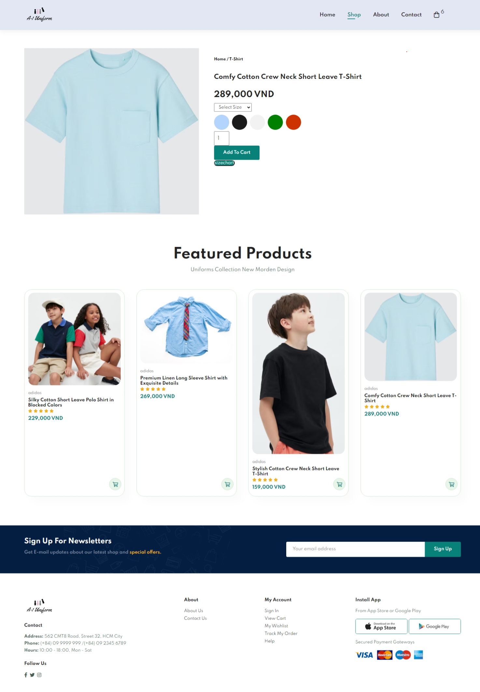

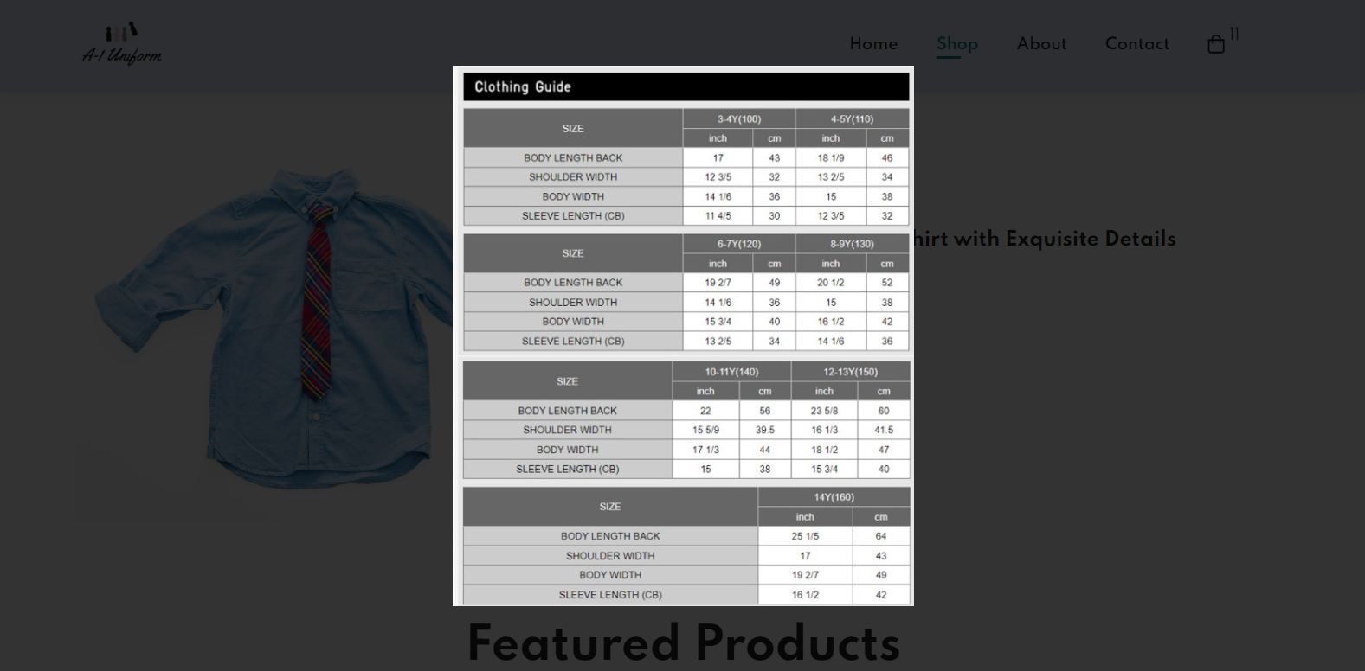

|  |  |  |  |  |  |
| --- | --- | --- | --- | --- | --- |
| Field Name | Control Format | Validation Rule | Data Type | Default Value | Trigger Event |
| <product picture> | Image | Display the picture of the viewing product.  Each product has only one picture. | CHAR | - | - |
| Select Size | Single-selection dropdown list | On Click, dropping the corresponding sizes list of the viewing product.  Each product has its own size list.  Size selection is not mandatory. | CHAR | Display the label:  Select Size | On Click |
| <product colors> | Button with border-radius of 50% | Display all available colors of the viewing product.  Each product has its own selection of colors.  It is obligatory to select the color.  Only one color is allowed to opt at a time. | Color code | - | On Click |
| Add to Cart | Button | On Click, the line item (=product item with selected color and/or size) is automatically added to the shopping cart.  The notification of the Cart icon is auto-incremented its number by the added quantity of the line item. | Text | Enabled | On Click |
| Size Chart | Button | Display an on-screen pop-up that contain a picture of size charts measurements | - | Enabled | On Click |

#### UC#13: Check out

**UC#13 | Activity Flow**

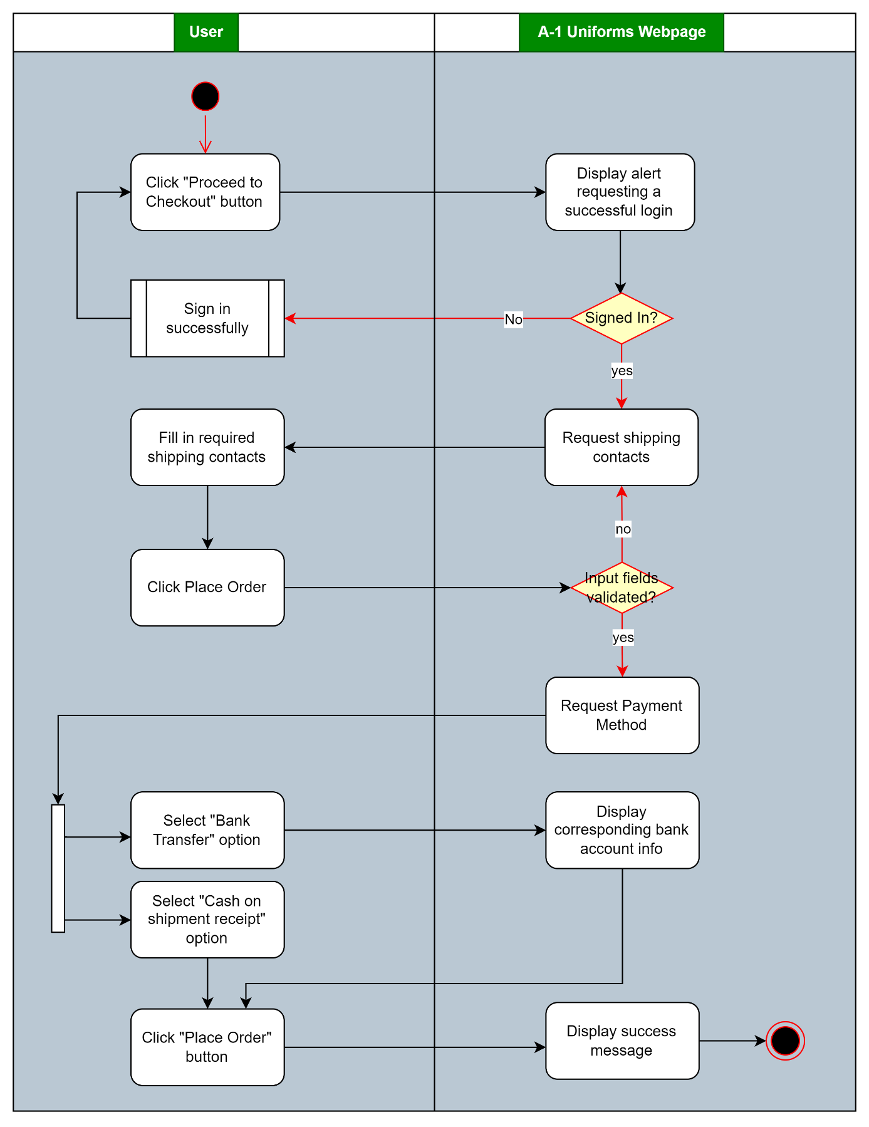

**UC#13 | Screenshots**

***Shipping***

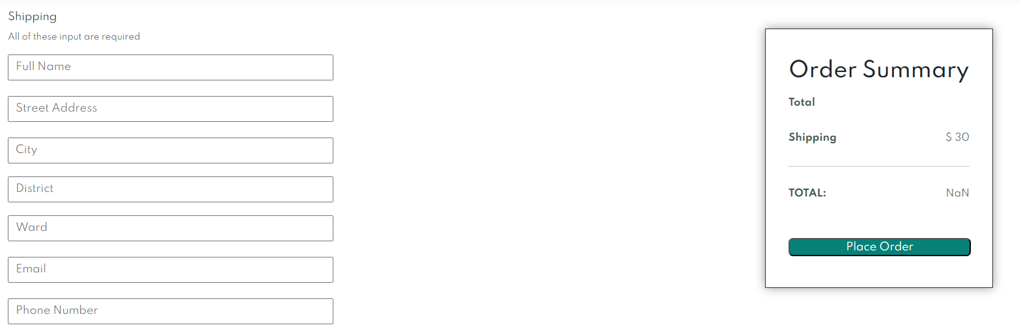

***Payment Method***

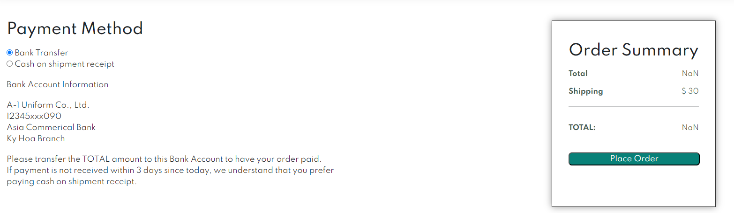

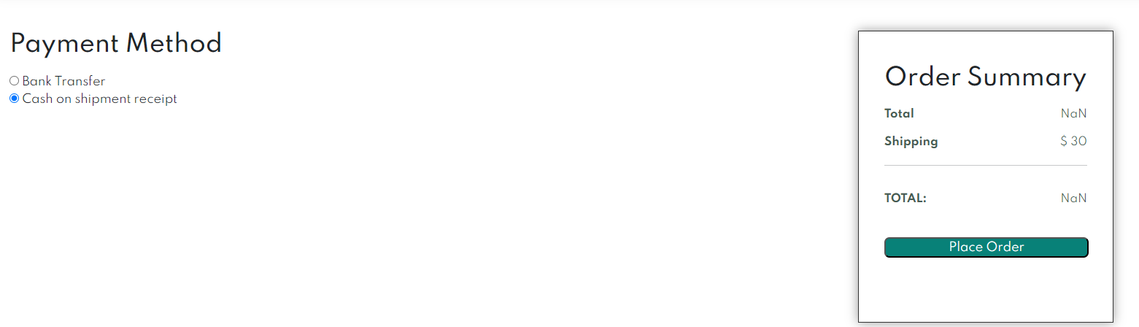

**UC#13 | Entry Fields**

|  |  |  |  |  |  |
| --- | --- | --- | --- | --- | --- |
| Field Name | Control Format | Validation Rule | Data Type | Default Value | Trigger Event |
| *Order Summary* (common for both *Shipping* and *Payment Method*)  *Initially, we made it through the validation check rules that we wanted.*  *However, when linking these two pages into the work. It didn’t go that well ☹.*  *We were desperately to seek for a solution and haven’t made it yet.* | | | | | |
| Total | Cell (Label) | Display the corresponding total price for all carted items  Format: {#} VND | Positive number | - | - |
| Shipping | Cell (Label) | Display the default shipping fee  Format: {#} VND | CHAR | 30 VND | - |
| TOTAL | Cell (Label) | Display the sum of the above amounts  Format: {#} VND | Positive number | - | - |
| *Shipping* | | | | | |
| Full Name | Input field | Allow free text input.  It’s mandatory and not nul. | CHAR (500) | Corresponding placeholder | On Click and each character typing |
| Street Address | Input field | Allow free text input.  It’s mandatory and not nul. | CHAR (500) |
| City | Input field | Allow free text input.  It’s mandatory and not nul. | CHAR (500) |
| District | Input field | Allow free text input.  It’s mandatory and not nul. | CHAR (500) |
| Ward | Input field | Allow free text input.  It’s mandatory and not null. | CHAR (500) |
| Email | Input field | Allow email format only  It’s mandatory and not null. | CHAR (500) |
| Phone Number | Input field | Allow email format only  It’s mandatory and not null. | CHAR (500) |
| *Payment Method* | | | | | |
| <method options> | Radio Buttons | Include two options:   * Bank Transfer * Cash on shipment receipt   Display the Order Summary card only if one of the payment option is selected.  Upon Bank Transfer is opted, system display “Bank Account Information  A-1 Uniform Co., Ltd. 12345xxx090 Asia Commerical Bank Ky Hoa Branch  Please transfer the TOTAL amount to this Bank Account to have your order paid. If payment is not received within 3 days since today, we understand that you prefer paying cash on shipment receipt.” | - | - | On Click |

## Send Feedback/ Request

### Use Cases

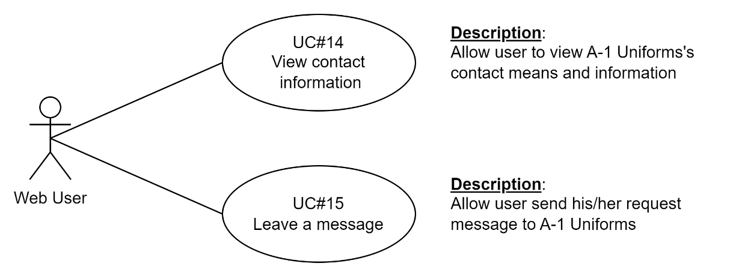

### Use Cases Description

#### UC#14: View Contact Information

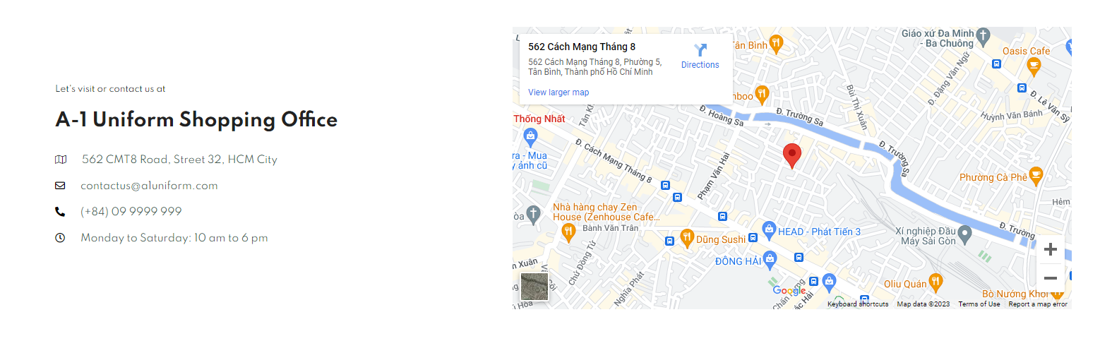

Left Side: For user information view only. No validation rule is added.

Right Side: The corresponding map inframe is validated against the right-handed address.

#### UC#15: Leave a Message

|  |  |
| --- | --- |
| Path | 1. User clicks Help entry from Navigation Footer 2. User clicks Contact entry from Navigation Header 3. User clicks “Contact Us” text from all products categoried as Uniform Sets from the Shop page. 4. User clicks “Explore More” from Homepage |
| Pre-conditions | None |
| Trigger | On Click |
| Post-condition | The Contact Us page is displayed  For routes 2 and 3, navigate directly to Leave a message section of Contact Us page |

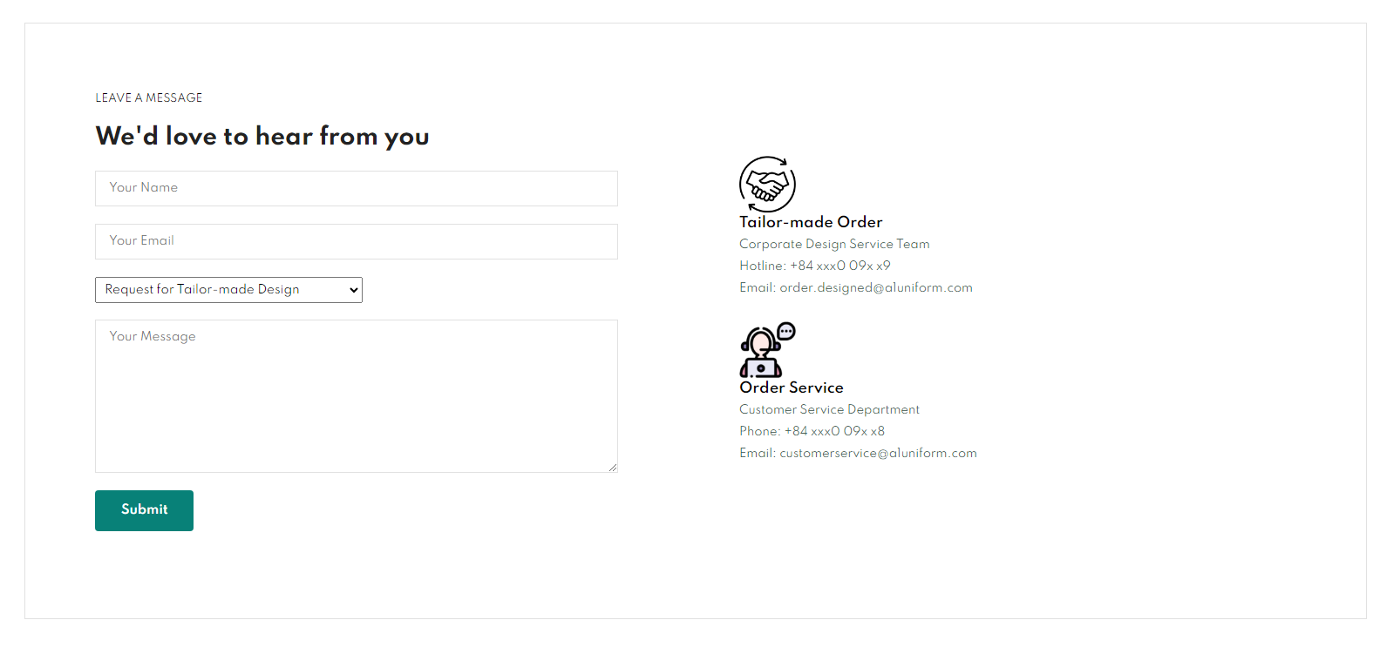

|  |  |  |  |  |  |
| --- | --- | --- | --- | --- | --- |
| Field Name | Control Format | Validation Rule | Data Type | Default Value | Trigger Event |
|  | | | | | |
| Your Name | Input Field | Accept free text  Mandatory, not null | Text | - | On Click and On each character typing |
| Your Email | Input Field | Accept free text (so that users can input both email, mobile number or his/her organization name).  Mandatory, not null | CHAR | Display the label:  Select Size | On Click |
| <dropdown> | Single selection dropdown | On Click, drop a list of two options   1. Request for Tailor-Made Design; 2. Send Feeback on My Received Order | CHAR | First option | On Click |
| Your Message | Input Paragraph Field | Accept free text  Mandatory, not null | CHAR(500) | - | On Click and On each character typing |
| Submit | Button | Trigger the form submission | - | Enabled | On Click |

# THE END